

 | EARLY BOOKING PRICE¹  $1499²  ($150 deposit to secure spot)  ¹ Price and deposit amounts guaranteed until Oct 31.  ² Per person/double occupancy.  *Transportation to and from Billings not included*
  JOIN OUR TOUR OF
  Missouri River Country
  of Montana!
  Join author, adventurer, and presenter Larry Campbell as he heads back to Montana and goes "Rollin Down the River" again!
  AUGUST 3 – 10, 2019
  Tour Includes:
  - Motor coach transportation (from Billings MT), lodging, most meals.
  - Free signed copy of Rollin’ book
  - Little Big Horn National Monument &
  Custer’s Battlefield
  - Beautiful Mo River & Montana scenery
  - Official Source of Missouri River at Three Forks
  - Helena: Montana State Capitol, St. Helena Cathedral, Trolley Tour, City Guide, River Boat tour, Gates of the Mtns.
  - Great Falls: Lewis & Clark Interpretive Center, Waterfalls & Dams, Giant Springs; world’s largest freshwater spring & world’s Shortest River, CM Russell Museum
  - Fort Benton: Oldest building in MT, old River levee, MO River ‘Breaks’
  - Many Lewis & Clark landmarks/sites
  - Much more!
  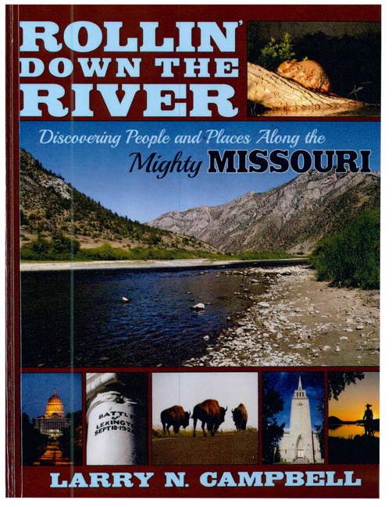

  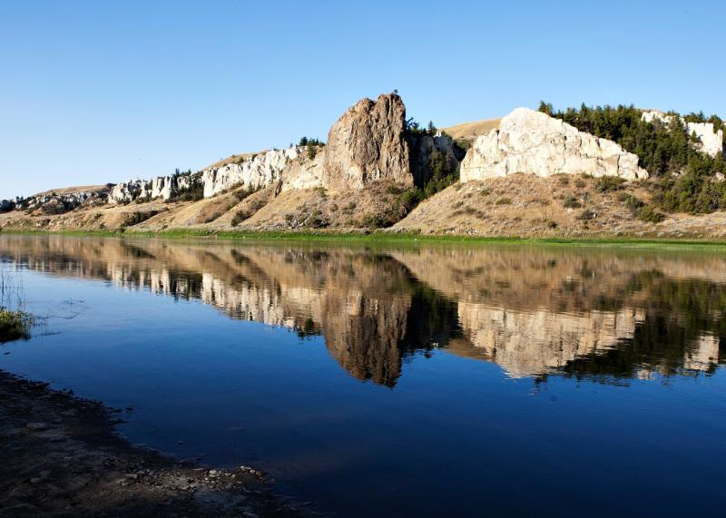
  For Reservations Contact
  

1-800-463-4254 or 417-335-2332
or e-mail: Bransonvac@aol.com

SOME FURTHER INFORMATION

The basic (per/person, double/occupancy) rate for the tour itself will be $1499. Rates are available for single, triple, and quadruple occupancy, as well.

Other quick things to note, FYI:
- We have tried to keep the initial deposit as low as possible - $150 - so you can secure your place(s). This deposit (and the trip price) are guaranteed until Oct 31.
- Depost is non-refundable but IS transferable.
- For maximum overall flexibility, transportation to/from Billings is not included, but Ozark Country Travel will book flights for you, if desired.
- Travel insurance WILL be available later.
While there will be a minimum number of seats required to make the trip 'go', there will also be a maximum enrollment of 54 - 56 as well. We already have more than that on the 'Prospects List', with registrations already coming in, and we are still a year away, so the sooner you secure your spot, the better.

QUESTIONS? If your questions are general or related to the trip itself (itinerary, etc) feel free to contact me (by e-mail or phone). I'll actually be happy to try to answer any questions, but if the questions concern pricing, insurance, flight arrangements, etc, it might be quicker to contact Carl Wade at Ozark Country Vacations (800-463-4254 or 417-335-2332), who is very good to work with.

Anything else? Contact Larry at larrycampbell@missouristate.edu or 417-337 – 2206.

Already excited!! Montana and the MO River, here we come!!

